Avi Load Balancer (NSX ALB)
Architecture Overview & Production Monitoring Metrics
Reference document for a Python + MongoDB monitoring tool

1. The mental model
Avi splits cleanly into a control plane and a data plane. Almost every confusion about Avi dissolves once you know which plane a component lives in.
- Control plane = the Controller (the brain). It holds config, serves the UI / REST API, and collects analytics. It never touches production traffic.
- Data plane = the Service Engines (SEs) (the muscles). They terminate SSL, inspect HTTP, pick a backend, and forward packets. They make no policy decisions on their own.
Controllers and SEs talk to each other over a management network: config flows down, metrics and logs stream up.

2. Two views of the system
A common source of confusion: in the traffic flow, the Virtual Service comes first (it is the entry point the client connects to) and the SE does the work underneath. But in the architecture / containment view, the SE VM is the host and the VS is a logical tenant placed on it. One SE hosts many VSes; one VS can span multiple SEs (Active/Active).
Both views are correct — they just show different relationships. We include a separate diagram for each.

2.1 Traffic flow — how a request moves
This diagram follows a single request from client to application (top to bottom). The numbered steps show the order of processing. Notice that the SE VM contains two internal processes — se_dp and se_agent — each with a different role.
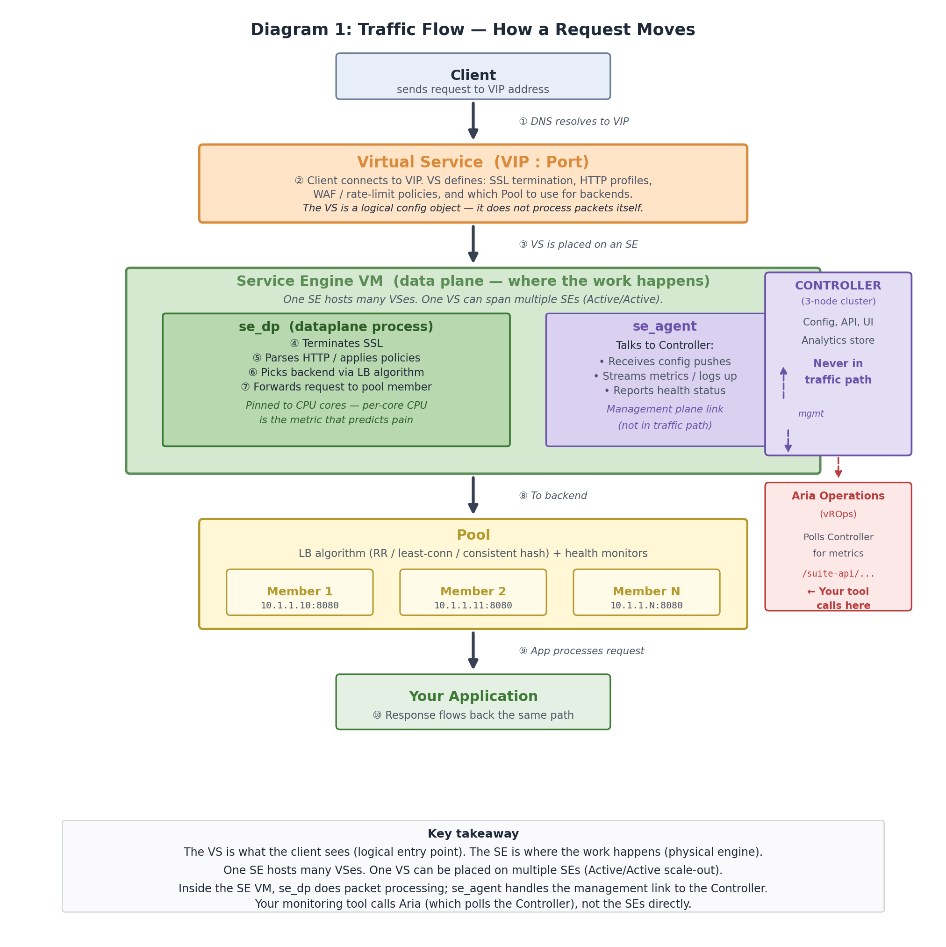

2.2 Architecture — what lives inside what
This diagram shows the nesting of components. The SE VM is the outer container; inside it run two processes (se_dp and se_agent) and zero or more Virtual Services as logical config objects. VS-A appears on both SE VMs to illustrate Active/Active scale-out. The monitoring tool sits at the bottom, calling Aria Operations (which polls the Controller).
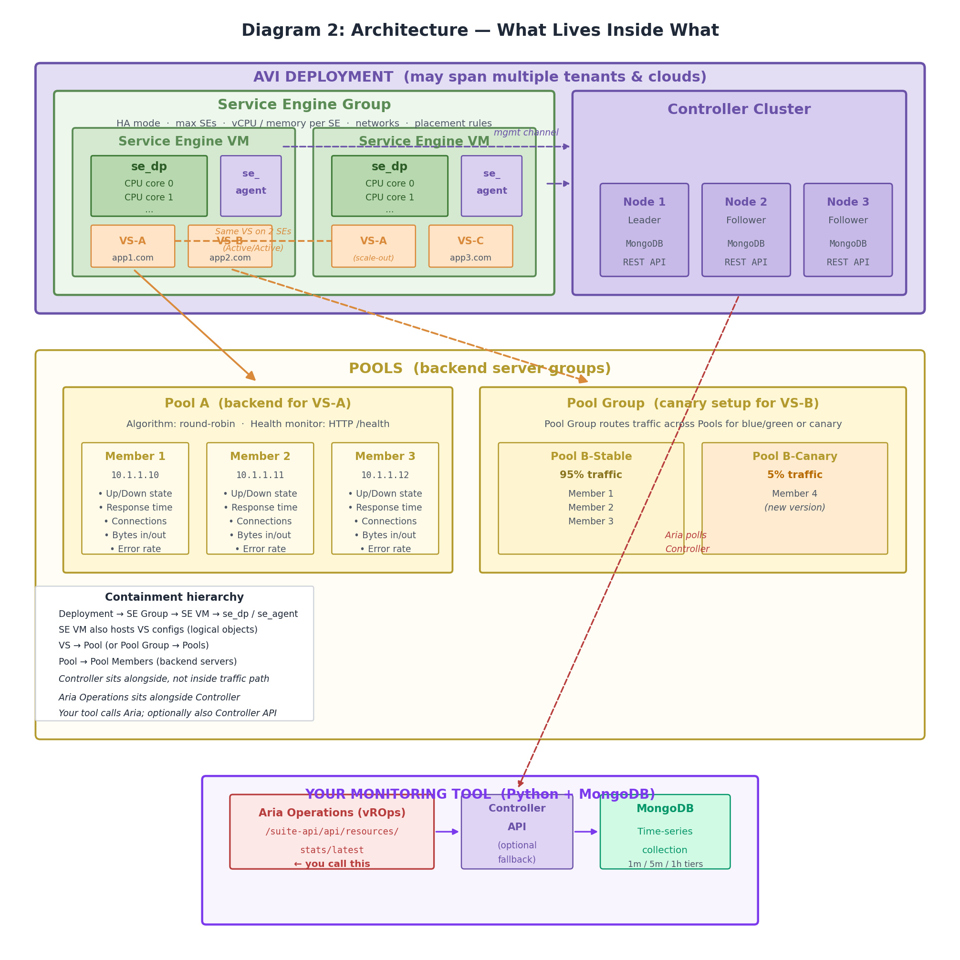

3. The components, one by one

3.1 Controller
Typically deployed as a 3-node cluster (one leader, two followers) for HA. Responsibilities:
- Stores all configuration and analytics.
- Serves the UI, REST API, and CLI.
- Pushes config down to Service Engines.
- Aggregates metrics streamed up from SEs.
Relevant to your stack: the Controller internally uses MongoDB to store configuration and analytics, so the data model will feel familiar when you start poking at the API.

3.2 Service Engine VM — and what runs inside it
A Service Engine is a VM (or container, or bare metal) that actually does load balancing. One SE typically hosts multiple Virtual Services. But the SE VM is not a monolith — there are two key processes inside it:
Inside the SE VM: two processes
se_dp (dataplane process) — the packet engine. This is the process that terminates SSL, parses HTTP, applies policies, runs the LB algorithm, and forwards traffic. It pins to CPU cores for high-speed processing. When you see 'per-core CPU' in metric tables below, it is the se_dp dispatchers you are measuring.

se_agent (control agent) — the management sidecar. This process maintains the connection to the Controller, receives config pushes, streams metrics and logs up, and reports health. It is not in the traffic path. If se_agent dies, the SE continues forwarding traffic with its last known config, but the Controller loses visibility.

Why this matters for monitoring: most SE-level metrics (CPU, memory, packet drops) come from what se_dp is doing. But the health of se_agent determines whether those metrics actually reach the Controller (and therefore Aria). A silent se_agent failure means your dashboard looks frozen — old numbers, no alerts.

3.3 Service Engine Groups (SE Groups)
An SE Group is a template plus a pool of SEs that share common properties: HA mode, max SE count, vCPU / memory per SE, attached networks, placement rules. A Virtual Service is assigned to an SE Group, not to a specific SE — Avi then places it on SE(s) within the group.

HA modes (each changes what 'normal' looks like on dashboards)
- Legacy Active/Standby — classic 1:1 pairing. Simple, wasteful of capacity.
- Elastic HA N+M — N active SEs plus M buffer SEs; on failure, a buffer takes over. Good balance of efficiency and failover speed.
- Elastic HA Active/Active — all SEs active; a VS can be placed on multiple SEs with traffic distributed via ECMP / BGP or scale-out. Highest throughput, most complex. The same VS (e.g. VS-A) appears on multiple SEs — this is by design.

3.4 Virtual Services (VS)
A Virtual Service is what clients actually connect to — a VIP + port + protocol — along with associated profiles (TCP/UDP, SSL, HTTP), policies (WAF, rate-limit, redirects), and a Pool (or Pool Group) of backends. If you have used F5, a VS is roughly the equivalent of a virtual server.
VS is logical, SE is physical
The VS does not process packets — it is a configuration object that defines what should happen to traffic. The actual work is done by the se_dp process inside the SE VM where the VS has been placed. Think of the VS as an Nginx vhost config file and the SE as the Nginx process that serves it.

A VS is placed on one or more SEs within its SE Group, and Avi can move a VS between SEs for failover or scale-out.

3.5 Pools and Pool Members
A Pool is a set of backend servers behind a VS, plus an LB algorithm (round robin, least connections, consistent hash, etc.) and one or more health monitors (ping, TCP, HTTP, custom scripts).
A Pool Group is a set of pools used for blue/green, canary, A/B, and priority-based failover. Skewed traffic across pools in a Pool Group is often by design (e.g. a 95/5 canary split), not a bug.

4. Important note on the API you are using
You are calling VMware Aria Operations, not the native Avi Controller API
Endpoint: https://{internal_address}/suite-api/api/resources/stats/latest
This URL pattern (/suite-api/...) belongs to VMware Aria Operations (formerly vRealize Operations / vROps). You are pulling Avi metrics through Aria's management pack for Avi, not directly from the Avi Controller.
Implications you need to design around:

- Different data shape. Aria identifies everything as 'resources' with a resourceKind (e.g. AviVirtualService, AviServiceEngine, AviPool) and a resourceId (UUID). Metrics are referenced by statKey strings, not by Avi's native metric names.
- Polling lag. Aria collects from Avi on an interval (typically 5 minutes). 'Latest' in /stats/latest means 'latest that Aria has pulled', not real-time.
- Reduced metric surface. You only see what the Avi management pack exposes to Aria, which is a subset of the native Avi analytics. Things like per-dataplane-core CPU or detailed latency breakdowns may be aggregated or missing.
- Aria is an abstraction layer. If Aria itself is unhealthy (collector down, adapter broken), your monitoring goes blind even when Avi is fine. Monitor the Aria adapter health as its own tier.
- Authentication & pagination. Aria uses token auth (/suite-api/api/auth/token/acquire) and returns paged results — plan for both from day one.
Practical first steps: call /suite-api/api/adapterkinds to confirm the Avi adapter is present, then /suite-api/api/resources?resourceKind=AviVirtualService to inventory resources, then /suite-api/api/resources/{id}/statkeys to enumerate which metrics each kind exposes.
Worth checking with the Avi team: whether you can also get direct access to the Avi Controller API (/api/analytics/metrics/collection) for the metrics Aria doesn't expose.

5. Metrics by layer — what to collect and why
Think in four layers, plus one composite indicator Avi gives you for free.

5.1 Controller health
If the Controller is sick, you lose visibility and config-change ability — but traffic keeps flowing.
Metric | Why it matters in Production Support
CPU, Memory | Baseline load; sudden jumps usually correlate with API hammering or analytics backlog.
Disk usage on /var | Metrics and logs eat disk fast. Disk-full on a Controller = silent monitoring outage. Alert early (70%) and hard (85%).
Cluster state | Is there a leader? Are followers in sync? Split-brain or no-leader = control plane broken.
Process health | controller, metricsapi, analytics processes alive and responsive.
API response latency | If you're polling the API hard, rising latency means you're starving yourself; back off or batch.
Config push status | SEs that are out of sync with Controller config are ticking time bombs for incidents.

5.2 Service Engine health
This is the layer that fails most interestingly in production. Remember: most of these metrics describe what se_dp is doing.
Metric | Why it matters in Production Support
CPU overall + per dataplane core | Per-core is the one that actually predicts pain. An SE averaging 40% overall CPU can still drop packets if one dispatcher core is at 100%. This is a se_dp metric.
Memory | SEs hold connection tables and SSL session state in memory. Watch for sustained climb, not just level.
Packet drops (interface + dispatcher) | Non-zero and rising is always worth investigating — usually a capacity, NIC, or dispatcher-pinning issue.
Interface throughput + PPS | In and out, per interface. Compare against SE rated capacity and the underlying NIC / host.
Connection table size (current vs max) | Running out of connection slots causes weird, hard-to-diagnose application failures.
SSL CPS and SSL TPS | SSL handshakes are expensive. CPS spikes burn CPU fast; a sudden spike often points to client-side bug or an attack.
SE-to-SE HA heartbeat | Silent heartbeat issues cause phantom failovers. Watch latency and loss on the heartbeat path.
Controller connectivity / SE state | Is se_agent connected to Controller? Is the SE primary or secondary for each VS? State flaps = unstable placement.

5.3 Virtual Service metrics
This is where SREs and app owners usually care most, because a VS maps to an application.
Metric | Why it matters in Production Support
Throughput in / out (Mbps) | Baseline and peak by time-of-day; enables capacity planning and spots sudden traffic shifts.
Connections per second (CPS) | New connection rate. Spikes burn SE CPU and SSL resources.
Concurrent connections | Different failure mode from CPS — long-lived connections fill connection tables rather than burning CPU.
Requests per second (L7) | For HTTP VSes, the real app-load metric.
End-to-end latency (4 segments) | Avi splits latency into client RTT, SE processing, server RTT, application response time. Gold for blame assignment.
HTTP 2xx / 3xx / 4xx / 5xx mix | Response-code distribution is your fastest app-health signal. Watch the ratio, not just absolute 5xx count.
SSL handshakes / sec + SSL errors | Certificate problems, cipher mismatches, client retries — all surface here first.
Policy drops | WAF blocks, rate-limit drops, ACL denies. Spikes here may be attacks, or a legitimate change breaking policy.
Connection errors / resets | TCP RSTs from clients or backends often point to MTU, idle-timeout, or backend crash issues.
Health Score + Apdex | Composite at-a-glance numbers. Good for dashboards, not a replacement for raw metrics.

5.4 Pool and Pool Member metrics
Metric | Why it matters in Production Support
Up members / Total members | Headline pool health. One down under load = degraded; two down in a three-member pool = incident.
Member up/down state + last health-monitor failure reason | The 'why' matters as much as the 'what' — 404 on health URL vs. TCP timeout vs. cert failure are three different problems.
Response time per member | Slow-member detection. A member that's up but slow is often the worst production experience.
Open connections per member | Reveals persistence misconfig or capacity mismatch between members.
Bytes in / out, requests/sec per member | Used for load-distribution skew checks.
Load-distribution skew | Derived metric: if round-robin is configured and one member is taking 80% of traffic, something is wrong.
Error rate from a specific member | Helps you distinguish 'the app is broken' from 'one node is broken'.

5.5 Composite: Health Score and Apdex
Avi computes a Health Score (0-100) for Virtual Services, Pools, Pool Members, and Service Engines. It is a composite of performance, anomaly, resource, and security sub-scores.
It is not a substitute for raw metrics — composites hide detail — but it is a great first-pass signal. A VS dropping from 90 to 60 tells you 'something changed here, go look.' Pair it with Apdex (for L7 services) for two strong at-a-glance dashboard numbers.

6. Practical advice for the monitoring tool

6.1 Scope the real metric catalogue before coding
Because you are going through Aria, do not assume Avi's native metric list applies. Enumerate once: list resource kinds, list resources per kind, list statkeys per resource. Then choose the subset you actually care about (typically 15-25 statkeys cover 95% of production-support needs).

6.2 Decide your cardinality budget in Mongo early
Per-VS, per-pool-member, per-SE, per-minute metrics get voluminous fast. Pick a retention tier strategy before you start:
- 1-minute resolution retained for 7 days (hot, queryable by ops).
- 5-minute resolution retained for 30 days (warm, for trending).
- Hourly roll-ups retained for 1 year (cold, for capacity planning).
Consider a time-series collection (native since Mongo 5.0) keyed by resource_id with metric and timestamp — automatic bucketing and much smaller on-disk footprint.

6.3 Separate polling from alerting
Make the collector a dumb pipeline: fetch -> normalize -> store. Alerting rules read from Mongo and are stateless where possible. This lets you replay, re-aggregate, and test rules without touching the collector.

6.4 Watch the monitoring tool itself
Add meta-metrics: successful poll count per resource, last-successful-poll age, Aria API error rate, and collector lag. Your first production incident in this tool will be 'we lost visibility but nobody noticed for 2 hours.'

6.5 Ask the Avi team three questions
- Which tenants and clouds exist? Multi-tenant Avi scopes everything; if missed, your tool will silently only see one tenant.
- Which HA mode is each SE Group in? It shapes what 'normal' looks like per VS.
- Can we also get a read-only user on the Avi Controller as a fallback for the metrics Aria doesn't expose?

7. Quick glossary
Metric | Why it matters in Production Support
Controller | 3-node cluster running the control plane; config, UI, API, metrics aggregation.
Service Engine (SE) | Data-plane VM/container/bare-metal that handles actual traffic. Contains se_dp and se_agent.
se_dp | Dataplane process inside the SE VM. Pins to CPU cores. Does all packet processing (SSL, HTTP, LB, forwarding).
se_agent | Control agent inside the SE VM. Maintains link to Controller, streams metrics, receives config. Not in traffic path.
Service Engine Group | Template + pool of SEs sharing HA mode, sizing, networks, placement rules.
Virtual Service (VS) | Client-facing VIP + port + profiles + policies + pool. Logical config object placed on SE(s). Maps to an application.
Pool | Backend servers behind a VS, plus LB algorithm, persistence, and health monitors.
Pool Group | A set of pools for canary / blue-green / A-B / priority failover.
Pool Member | Individual backend server inside a Pool.
VIP | Virtual IP — the address clients connect to for a VS.
Health Score | Avi-computed composite (0-100) across performance, anomaly, resource, security.
Apdex | Application Performance Index, computed for L7 services — user-satisfaction proxy.
Aria Operations / vROps | VMware's monitoring platform. The /suite-api endpoint lives here, not in Avi.

